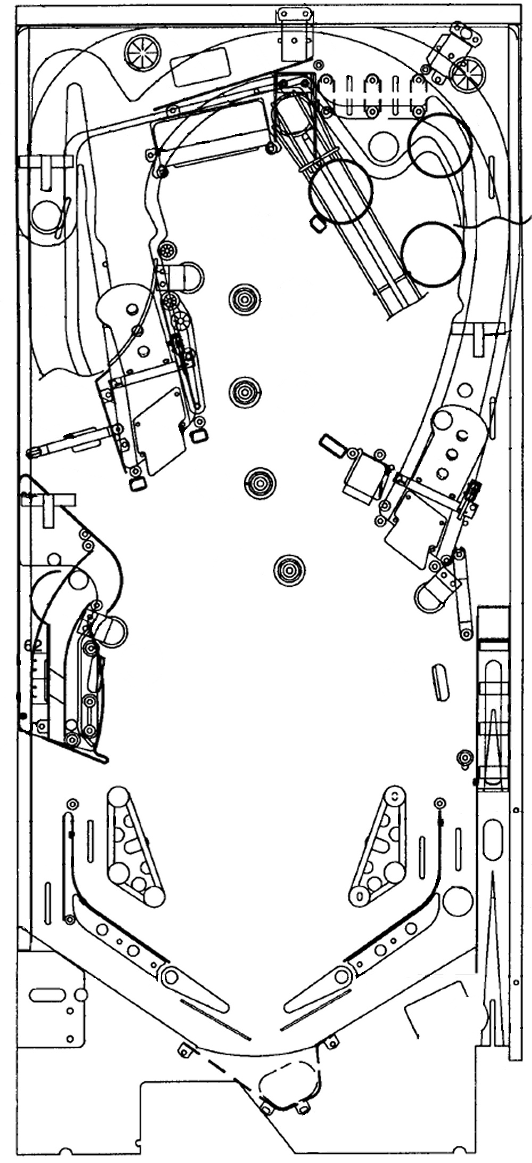
3/16”
3/16”
3/16”
3/16”
3/16”

27/64”

27/64”

27/64”

27/64”

Rubber
Sleeve

Rubber
Sleeve

Rubber
Sleeve

Rubber
Sleeve

27/64”

7/16”

27/64”

3/4”

3/4”

1”

2”
(2 st)

2 1/2”

Plunger
tip

Flipper
ring

3”
(2 st)

5/16”

5/16”

3/16”

1”

27/64”
3/16”

